IBM Watson Studio – Report Authoring Workshop

Prerequisites: IBM Cloud Setup, Cloud Object Storage service instance, and Watson Studio service instance. See the Setup and Installation Guide for details.

In this workshop you will learn how to create a financial report in Watson Studio using a dashboarding service. Your financial report will be split into three tabs, and each of the following tutorials corresponds to one of the tabs.

NOTE: The sample data should be provided to you along with this workshop, under the filename “**Sales and Marketing.csv**”.

You should be able to complete any one of these tutorials in approximately 30 minutes, depending on loading and running times.

Tutorial 1 – Percentage Data

This tutorial will teach you how to make a Stacked Column chart as well as display percentage data for gross profit by region and by brand. The business case for this tutorial is: “I am the CEO, and I want to see the performance data for products, brands and regions.” Below is an image of the finished dashboard product of this tutorial for reference purposes throughout the instructions.

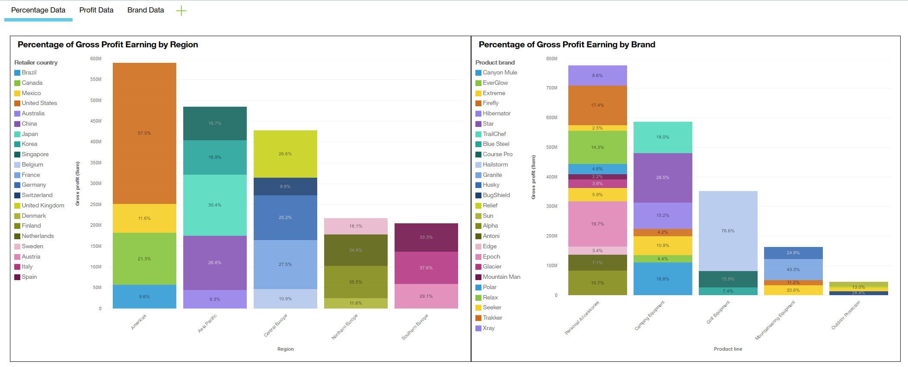

Step 1: Starting the project.

1. 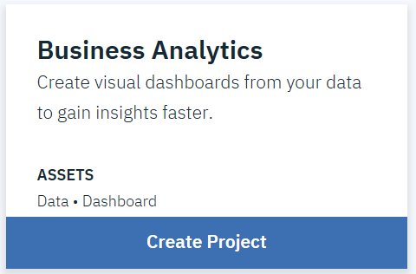Go to <https://dataplatform.cloud.ibm.com/> and login with your IBM Cloud account details.
2. Click **Create a Project**, then **choose** the Business Analytics card. You may need to scroll down.
3. On the **Select a Region** prompt, choose **US South** from the drop-down menu.
4. **Name your project**, ensure your **Storage** field is filled with the name of your Cloud Object Storage service instance, then under **Cognos Dashboard Embedded** either choose a service instance which you have already provisioned or follow the steps to provision one right now.
5. Click **Add to project** and select **Data**.
6. Upload the **Sales and Marketing.csv** file provided to you alongside this workshop.
7. Click the **Add to Project** button, then choose the **Dashboard** card. From there, name your dashboard and select the same **Cognos Dashboard Embedded** service you selected earlier.
8. 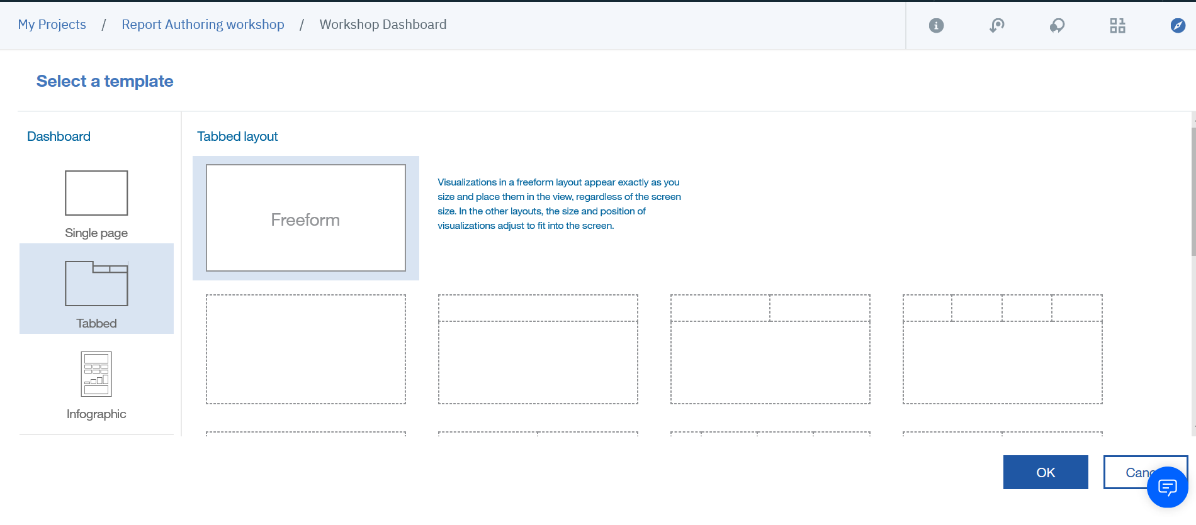From the Templates page, choose a **Freeform** layout from the **Tabbed** section and click **Ok**.



1. Inserting image...From the sidebar on the left, click the data sources icon , then click the plus icon next to “**Selected Sources**”. On the selection screen choose Data assets, choose “**Sales and Marketing**”, then click the **Select** button.
2. Inserting image...Click the tab labelled “**Tab1**” at the top of your dashboard, then click the **pencil icon** and change the tab name to “**Percentage Data**”.
3. From the sidebar on the left, click the Visualisations icon then drag the Stacked Column visualisation onto your dashboard.
4. The ‘Design Mode’ window for this visualisation should automatically open up and the side bar will auto-navigate to the data sources tab. Click the data file from earlier, then expand the next data item with the same name.
5. 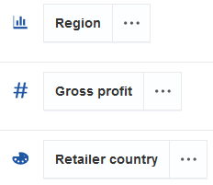From the selection of data items at your disposal:
   1. Drag “**Region**” into the “**Bars**” field of the visualisation.
   2. Drag “**Gross Profit**” to the “**Length**” field.
   3. Drag “**Retailer Country**” to the “**Colour**” field.
   4. Now click the **Collapse** button Inserting image... in the top right corner of the visualisation window.
6. 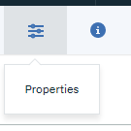Move and re-size the chart on your dashboard as you see fit. Make sure your chart is selected, then click the **Properties** button in the toolbar at the top of the page.
7. In the **Properties** sidebar, under the Details tab:
   1. Under “**Item Axis Label Orientation**” choose “**Rotate 45 Degree**” from the drop-down menu.
   2. Check the “**Show Value Labels**” box, then under “**Value Label Format**” choose “**Percentage of Category**” from the drop-down menu.
   3. Check the “**Contrast Label Colour**” box.
   4. From the “**Legend Position**” drop-down menu, choose the “**Left**” option.
8. In the Properties sidebar, under the General tab:
   1. Click **Border Colour** and choose the **black** option.
   2. Click the “**Show Title**” checkbox, then type “**Percentage of Gross Profit Earning by Region**”.
9. Close the Properties sidebar by clicking the Properties button again, then open the Design Mode window for your chart again by clicking the Expand Window button in the top right corner of the visualisation.
10. On the **Gross Profit** card in the **Length** field, click the ellipses button and click **Format**, then choose the **Abbreviate** option.
11. Again, on the **Gross Profit** card in the **Length** field, click the ellipses button and click **Sort**, then choose the “**Sort Descending**” option. Collapse the **Design Mode** window again. Inserting image...
12. In the left sidebar, click the **Visualisations** tab, then drag another **Stacked Column** chart to the right of your previously made chart.
13. 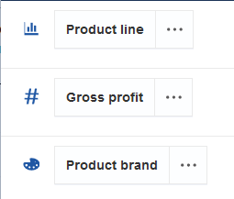From the data source sidebar on the left:
    1. Drag **Product Line** to the **Bars** field.
    2. Drag **Gross Profit** to the **Length** field.
    3. Drag **Product Brand** to the **Colour** field.
14. Click the ellipses button on **Gross Profit**, then in “**Format**” choose “**Abbreviate**” and in “**Sort**” choose “**Sort Descending**”. Collapse the Design Mode window with the button in the top right corner.
15. In the **Properties** sidebar, under the **Details** tab:
    1. Under “**Item Axis Label Orientation**” choose “**Rotate 45 Degree**” from the drop-down menu.
    2. Check the “**Show Value Labels**” box, then under “**Value Label Format**” choose “**Percentage of Category**” from the drop-down menu.
    3. Check the “**Contrast Label Colour**” box.
    4. From the “**Legend Position**” drop-down menu, choose the “**Left**” option.
16. In the **Properties** sidebar, under the **General** tab:
    1. Click **Border Colour** and choose the **black** option.
    2. Click the “**Show Title**” button, then type “**Percentage of Gross Profit Earning by Brand**”.
17. Adjust and move the charts so that they appear side by side, as in the picture below.

By completing this first tab of your dashboard, you have learned one method of reporting financial data in a visual manner, while also using sorting and formatting to present the data cleanly.Tutorial 2 – Profit Data

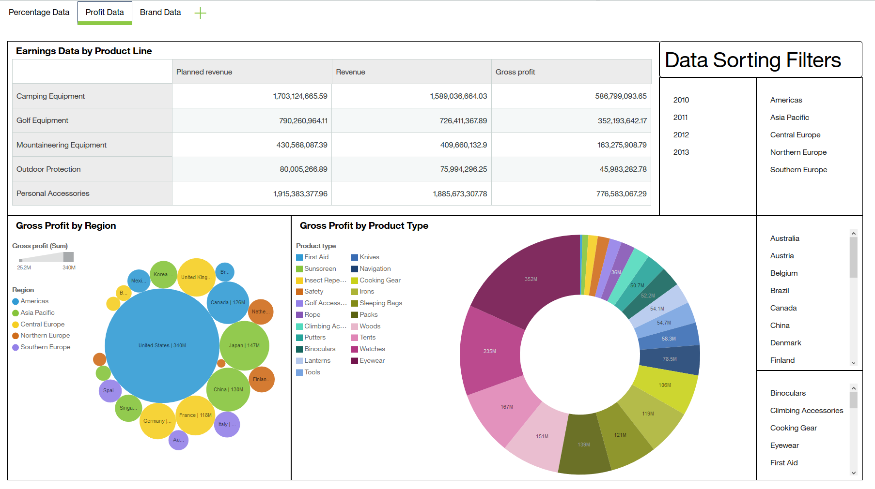This tutorial will teach you how to make a Pie chart, a Bubble chart, a Crosstab, and List filters. The business case for this tutorial is: "I am a corporate executive and I want to assess our sales figures over different regions, countries and product types. I also so want to sort by region and product type.” Below is an image of the finished dashboard product of this tutorial for reference purposes throughout the instructions.

1. Click the plus icon next to your Percentage Data tab, choose freeform then name this new tab “**Profit Data”**.
2. 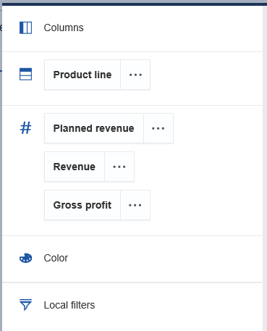From the **Visualisations** tab in the left sidebar, drag a **Crosstab** visualisation onto your dashboard.
3. From the data source sidebar on the left:
   1. Drag **Product Line** to the **Rows** field.
   2. Drag **Planned Revenue** to the **Values** field.
   3. Drag **Revenue** to the **Values** field beneath the previous item.
   4. Drag **Gross Profit** to the **Values** field beneath the previous items.
4. In the **Properties** sidebar, under the **Details** tab, check the **Hide Summaries** box.
5. In the **Properties** sidebar, under the **General** tab:
   1. Click **Border Colour** and choose the **black** option.
   2. Click the **Show Title** button, then type “**Earnings Data by Product Line**”.
6. Adjust this visualisation so that all the data can be seen, while also leaving space below and to the right for the next few visualisations (see picture at the beginning or end of this tutorial for clarity).
7. 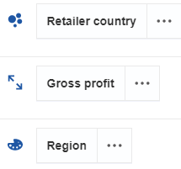From the **Visualisations** tab in the left sidebar, drag a **Packed Bubble** chart onto your dashboard.
8. From the **data source** sidebar on your left:
   1. Drag **Retailer Country** to the **Bubbles** field.
   2. Drag **Gross Profit** to the **Size** field.
   3. Drag **Region** to the **Colour** field.
9. Click the ellipses button on the **Gross Profit** card, then under “**Format**” click the “**Abbreviate**” option.
10. Collapse the **Design Mode** window with the button in the top right corner, then move your visualisation so that it is aligned directly underneath the **Crosstab** and flush with the left wall of the page.
11. Keep the **Packed Bubble** visualisation selected and click the **Properties** button in the top toolbar.
12. From the **Properties** sidebar, under the **Details** tab:
    1. Under **Item Label Format**, choose the “**Both**” option.
    2. Check the **Contrast Label Colour** box.
    3. Under **Legend Position**, choose the **Left** option.
13. From the **Properties** sidebar, under the **General** tab:
    1. Click **Border Colour** and choose the **black** option.
    2. Click the “**Show Title**” button, then type “**Gross Profit by Region**”.
14. 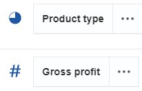To the right of your **Packed Bubble** chart, still underneath your **Crosstab**, drag a **Pie** chart from the **Visualisations** tab in the left sidebar.
15. From the **data source** sidebar on the left:
    1. Drag **Product Type** to the **Segments** field.
    2. Drag **Gross Profit** to the **Size** field.
16. Click the ellipses button on the **Gross Profit** card, then under **Format** click the **Abbreviate** option.
17. Collapse the **Design Mode** window, then with the **Pie** chart selected, open the **Properties** sidebar.
18. From the **Properties** sidebar, under the **Details** tab:
    1. Check the **Contrast Label Colour** box.
    2. Set the **Donut Radius** to 50%.
    3. Under **Legend Position**, choose the **Left** option.
19. From the **Properties** sidebar, under the **General** tab:
    1. Click **Border Colour** and choose the **black** option.
    2. Inserting image...Click the “**Show Title**” button, then type “**Gross Profit by Product Type**”.
20. On the left sidebar, open the **Widgets** tab and drag a **Text** widget onto the dashboard, to the right of the **Crosstab** and aligned flush with the top of the page.
21. In the **Text** widget, enter “**Data Sorting Filters**”.
22. From the **Properties** sidebar, under the **General** tab, click **Border Colour** and choose the **black** option.
23. ****Adjust the **Text** widget so that it extends further to the right than the **Pie** chart does (see picture at beginning or end of tutorial for clarity).
24. ****On the left sidebar, open the **Visualisations** tab and drag a **List** visualisation onto the page to the space between the **Text** widget and the **Pie** chart, flush with the side of the **Crosstab**.
25. From the **data source** sidebar, drag **Year** to the **Level One** field, then collapse the **Design Mode** window.
26. Drag another **List** visualisation onto the dashboard to the right of the **Year** List.
27. From the **data source** sidebar, drag **Region** to the **Level One** field, then collapse the **Design Mode** window.
28. Repeat the creation of **List** visualisations with the **Retailer Country** data item, and the **Product Type** data item. Place them each under the **Regions** List (see image at the beginning or end of the tutorial for clarity).
29. Adjust each of the **List** visualisations to fit neatly in line together, then select all of them and under the **General** tab of the **Properties** sidebar, set the **Border Colour** to the **black** option.

In this tab of the dashboard, we arranged several charts into a helpful display. Use the filters by clicking them, to give yourself a deeper understanding of the data point by point rather than en-masse. The visualisations react to the filters you select, but you can also investigate the data by clicking the bubbles and segments of the charts.

Tutorial 3 – Brand Data

This tutorial will teach you how to make Table charts, calculations, and comprehensive data filters. The business case that we are using for this is "I am a manager at the local level and I want to know what products and brands I should stock for each product category. I also want yearly data and promotions data”. Below is an image of the finished dashboard product of this tutorial for reference purposes throughout the instructions.

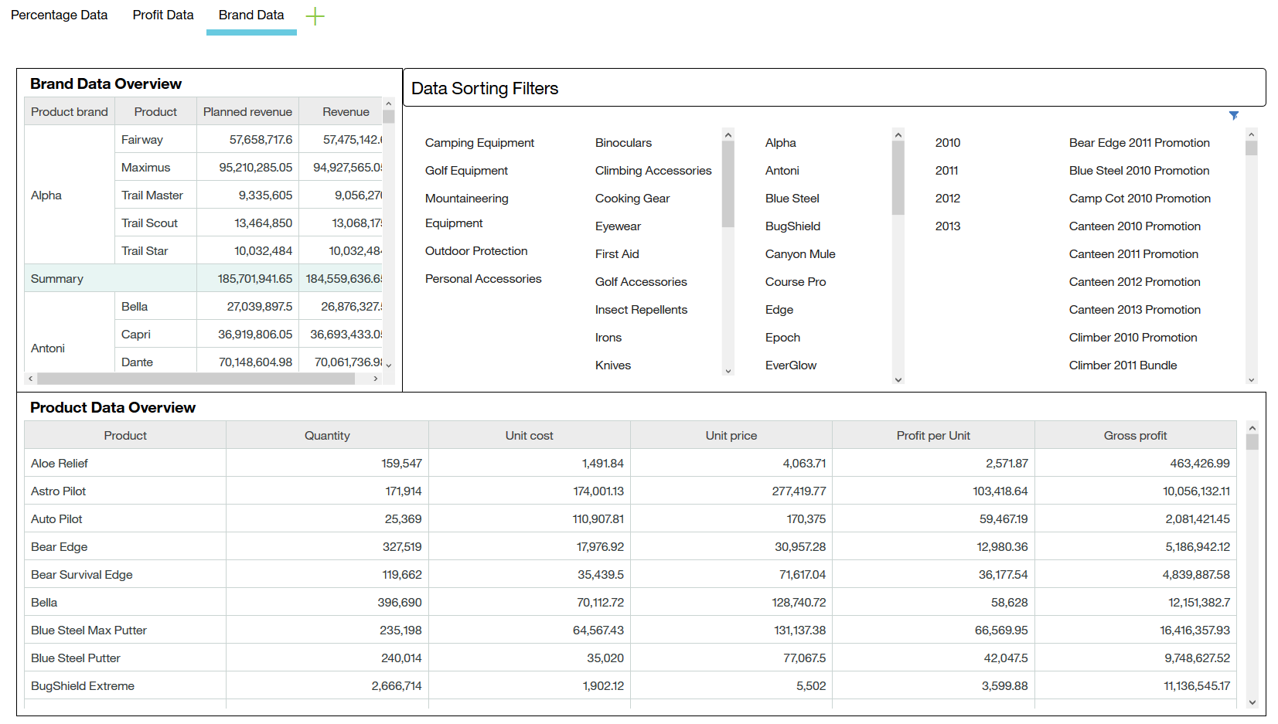

1. ****Make a new **Freeform** tab and name it “**Brand Data**”.
2. From the **Visualisations** tab on the left sidebar, drag a **Table** onto your dashboard.
3. 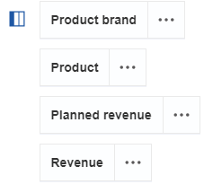Drag the following data items, in the following order, into the **Columns** field of the **Table**:
   1. **Product** **Brand**
   2. **Product**
   3. **Planned Revenue**
   4. **Revenue**
4. In the **General** tab of the **Properties** sidebar:
   1. Click **Border Colour** and choose the **black** option.
   2. Check the **Show Title** box and type “**Brand Data Overview**”.
5. From the **Visualisations** tab on the left sidebar, drag a **Table** onto your dashboard.
6. 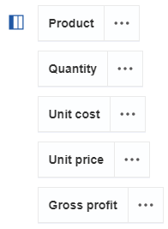Drag the following data items, in the following order, into the **Columns** field of the **Table**:
   1. **Product**
   2. **Quantity**
   3. **Unit Cost**
   4. **Unit Price**
   5. **Gross Profit**
7. Click the ellipses button on the **Unit Price** card, then click on **Calculation**.
8. Click the “**Use Calculation Editor**” text.
9. Change the **Name** text to read “**Profit per Unit**”.
10. Change the **Expression** text to read “**Sales_and_Marketing_csv.Unit_price – Sales_and_Marketing.csv.Unit_cost**”. Click **Validate** to make sure that the expression is valid, then click the **OK** button.
11. Drag the **Profit per Unit** card now in the **Columns** field from below **Gross Profit** to above **Gross Profit** and below **Unit Price**.
12. Click the ellipses button on the **Gross Profit** card, click **Sort**, then choose the **Sort Descending** option. Collapse the **Design Mode** window.
13. From the **Details** tab of the **Properties** sidebar, check the **Hide Summaries** box.
14. From the **General** tab of the **Properties** sidebar:
    1. Click **Border Colour** and choose the **black** option.
    2. Check the **Show Title** and type “**Product Data Overview**”.
15. Drag a **Text** widget from the **Widgets** tab on the left sidebar to the top of the page on the right of the “**Brand Data Overview**” Table.
16. In the Text widget, type in “**Data Sorting Filters**”, then change the **Border Colour** to **black** in the **Properties** sidebar.
17. Adjust the “**Product Data Overview**” Table so that all the columns are visible, then adjust the **Text** widget to match the length of the **Table** below it.
18. In the gap between the “**Data Sorting Filters**” Text widget and the “**Product Data Overview**” Table, create separate **List** visualisations for each of the following data items in the following order from left to right:
    1. **Product Line**
    2. **Product Type**
    3. **Product Brand**
    4. **Year**
    5. **Promotion Name**
19. Adjust each **List** visualisation so they line up neatly between the **Text** widget and the two **Table** visualisations (see the picture at the beginning or end of the tutorial for clarity).
20. Click the ellipses button on the **Promotion Name** card, then select **Filter**. Check the “**(no value)**” box, then click the **Invert** label and click the **OK** button. Collapse the **Design Mode** window.



In this last tab of the dashboard, we have authored a comprehensive numbers-driven report. By choosing options in any of the different filters, we can see how the figures associated with different brands and products fluctuate over different variables.